**Brooklyn torah gazette**

**For parshas vayigash 5782**

Volume 6, Issue 12 (Whole Number 267) 7 Teves 5782/ December 11, 2021

**Printed L’illuy nishmas Nechama bas R’ Noach, a”h**

For a free subscription, please forward your request to [***keren18@juno.com***](mailto:keren18@juno.com)

**The Tragedy of Underestimating**

**Our Own Potential for Greatness**

**By Daniel Keren**

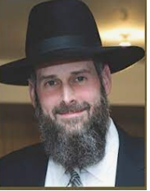

**Rav Yosef Viener**

One of the featured speakers at the recent Flatbush Hakhel Event on Thanksgiving Day was Rabbi Yosef Viener, the rav of Sha’ar Hashomayim shul in Monsey and the topic of his lecture was “Is There a Time to Give Up or Give In?”

Rabbi Viener began to speak about the concept of Kavi Hashem – Trust in Hashem. Everything is pre-planned, but we must know how to give ourselves and other chizuk (encouragement).

One of the biggest nisoyim that challenged Yosef HaTzadik was either his being sold by his brothers as a slave to a caravan travelling to Egypt or the constant temptations of Potiphar’s wife. But in the end, he passed both challenges with flying colors.

The smoking gun was Yosef’s kavod habris (respect for human dignity) by his not harming his master’s wife after she had seized his garment, even though allowing her to keep it would leave him in a most detrimental situation where she could successfully make a false accusation against him.

One might think that since he successfully overcame the test of respecting the dignity of Potiphar’s wife that he should have received from Hashem a clearly perceived reward. Yet what happened to Yosef was that he landed in a brutal primitive jail and stayed there for a very long time.

Rabbi Viener explained that it is at such times when people suffer setbacks after acting nobly that the Yetzer Hora (the Evil Inclination) comes and challenges one by saying “Why make the extra effort to be so good and this is your reward?”

**Falling into the Trap of Kefira**

Someone who had been double crossed after doing a favor to another person, once told Rabbi Viener that nice guys finish last. Rabbi Viener responded that such an attitude is nothing short of kefirah (a heretical denial of G-d’s existence.)

The reward for one’s mitzvahs is not primarily for this world (Olam Hazeh), but rather for Olam Habah (the world to come.) Yes, it is nice to get chizuk from Hashem when one does a great mitzvah. But life isn’t always the way one anticipates.

Once as the Chofetz Chaim was coming close towards completing his magnus opus – the Mishna Berura – an important work on halacha/Jewish law, his personal life was rocked by overwhelming tragic setbacks, including the untimely death of one of his sons – a great talmid chacham (Torah scholar). At the levaya (funeral service) for his son, he was overheard to be muttering, “You (the Yetzer Hora) are not going to stop me! You are not going to stop me! [from completing my project on publishing the Mishna Berura.]

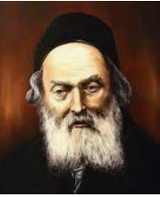

**The Chofetz Chaim**

Rabbi Viener explained that if one is in the middle of performing a great mitzvah and is rocked with distracting difficulties, one should realize that this is most probably the plot of the Yetzer Hora to cause on to give his important spiritual service.

Our job is to keep trying. People daven (pray) for many things. We know that not everyone is a billionaire. If Hashem doesn’t want you to be rich, it could be that He knows that wealth will not be beneficial for you. Maybe if you achieve the material wealth that

you long for and daven mightily for, it might cause you to stumble spiritually and use it to buy things such as a yacht that will just cause significant harm to your ruchnius (spirituality).

How long should a person daven for something that he desires and is not getting an answer from Hashem for that wish? In the case of Chana, the mother of Shmuel, she continued to daven for many years and her intentions was not for selfish reasons but for a child that would serve Hashem. Hashem answered Chana because He knew that Klal Yisroel would need a great leader in the future like Shmuel Hanavi.

One who is davening a long time for something if it for a good ruchnius purpose should continue to pray for that with the belief that when the right time to be answered might be sooner than later. One must realize that our purpose in life is to focus and perfect our ruchnius and everything else is simply a worthless distraction.

Rabbeinu Tam teaches that there may be weeks when nothing seems to going right for you. But we must know that life is like a circle and eventually things will turn around and become much better. Never give up!

If one is going through financially difficult times, one should not stop donating one’s money to tzedokah (charitable causes), even if you have to give less than you normally do. Similarly, if life has gone into a cycle of difficulties and painful challenges, don’t stop doing your normal performance of mitzvahs and study of Torah or you might spiritually decline and never recover.

If you know what your mission in this world is, Rabbi Viener says that it gives you the power to overcome the attempts of the Yetzer Hora to seriously derail you from your tafkid (purpose) in life.

*Reprinted from this week’s edition and email of The Jewish Connection.*

*\*\*\*\*\*\*\*\*\*\*\*\*\*\*\*\*\*\*\*\*\*\*\*\*\*\*\*\*\*\*\*\*\*\*\*\*\*\*\*\*\*\*\*\*\*\*\*\*\*\*\*\*\*\*\*\*\*\*\*\*\*\*\*\*\*\**

*Yosef said to his brothers, "I am Yosef; is my father still alive?"* (Gen. 45:3)

The first time the brothers came to Egypt, Yosef asked about his father. The second time they came he asked again. This time, Yosef wasn't just asking about his father. He was revealing himself as their brother by saying, in effect, "I am proving to you that I really am Yosef, because I'm only asking about my father, not my mother. I already know that my mother died many years ago. If I was an impostor, I wouldn't necessarily know that." (Imrei Yehuda)

*Reprinted from Reprinted from the 5757/1996 Vayigash edition of L’Chaim Weekly Compiled by Rabbi Moshe Bogomilsky and printed in Vedibarta Bam*

**Parshas Vayigash:**

**By What Currency Do**

**You Measure Success**

**By Rabbi Bentzion Shafier**

**Founder of TheSmuz.com**



“*And they related to him all the words of Yosef that he had spoken to them, and he saw the wagons that Yosef had sent to transport him, then the spirit of their father Yaakov was revived*.” — Bereishis 45: 27

For twenty-two years, Yaakov Avinu was in a state of mourning. His beloved son, the one who most closely followed in his ways, the one whom he envisioned as the leader of the next generation, had been taken from him — and the boy was still a youth. For all those years, Yaakov was inconsolable. Now the brothers had come back with the news: “Yosef is still alive!” At first Yaakov could not believe it — it just couldn’t be. The brothers convinced him that it was true by showing him the wagons that Yosef had sent.

Rashi explains that the wagons were a code. The last sugyah (Torah topic) that Yosef had been learning with his father was eglah arufah, a calf that is killed for atonement. The Hebrew word egel, or calf, is similar to eglah, which means wagon. Yosef was using a play on words to refer back to the last topic that they discussed in their Torah studies. Once Yaakov saw the wagons, his mind was reminded of their last Torah discussion, and he knew that Yosef was alive. “No one else could have known this. It’s a clear sign that it’s Yosef. He is still alive!”

The problem with this Rashi is that it is difficult to imagine that Yosef would expect his father to vividly recall a conversation that they had had twenty-two years earlier. Even if Yosef had sent back a clear message, it would be difficult to imagine that Yaakov would remember a conversation that far back. But that isn’t what Yosef did. He sent the wagons as a cryptic hint. Why did Yosef assume that his father would recall their conversation from that? And how, in fact, did Yaakov make the connection?

The answer to this question lies in understanding the significance of certain events.

**Where Were You when Kennedy Died?**

Each generation has its defining moments. If you ask people who grew up in America in the 1960’s where they were when Kennedy was shot, many will be able to describe not only where they were standing when they heard the news, but even the details of the wallpaper of the room they were in.

In more recent times, if you ask someone, “Where were you on 9/11?” many people will vividly recall the exact part of the office they were standing in and who they were talking to when they heard about the Twin Towers going down. The same person who can’t remember what he had for breakfast this morning can clearly recall an event that happened years ago.

Certain events make an indelible impression upon us. Because of their significance and deep meaning, they become permanently etched into our minds. If we didn’t understand the implications of the moment, or if we didn’t view them as monumental, they would pass as just another one of the millions of events that we live through. But because we see these events as world-changing, as moments in history, they become part of us forever.

**The Avos Lived with a Very Different Value System**

This seems to be the answer to this Rashi. The Avos (forefathers) lived with a very different value system than we do. To them, their words of Torah and novel understandings of it were earth-shattering. Because they understood the value of Torah and the change that it brought to them and to the world they lived in, they recognized learning as one of the most significant activities a human can ever engage in. And so, they lived those Torah discussions as epic moments in time.

For that reason, the sugyah that Yaakov and Yosef last discussed was ever-present in Yaakov’s mind. It wasn’t just another detail in his day; it was a defining moment. That is why Yosef took it as a given that one of the first things that his father would think about when recalling him was their last Torah discussion, and therefore, the play on words would not be distant from his mind.

**Changing Currency**

One of the secrets to the Avos’ success was their clarity in values. They knew what was truly precious and how valuable it was. This is very different than what we typically experience. Most people we meet spend their lives with ever changing priorities; that which was so important at one stage becomes insignificant and irrelevant at another.

To a young boy growing up in America, sports are king. That’s what really counts in his world. But it doesn’t last. It is soon replaced by friends and being popular. As he matures, grades and what college he gets into become the measure of success. Within a short while, his career and making money are all that really matter. This phase passes as well, and then he finds himself willing to trade away huge amounts of his wealth to build his reputation. As he nears retirement, his health and then his future nursing home become his primary concern.

Throughout his existence, that which was precious and coveted at one point becomes devalued and traded away as new priorities take over. The currency is constantly changing. And so, while at each stage of life he may have done well, in the totality of what he has accomplished, it may not be much. Since he lived with an ever-changing system of values, he likely has not come even close to achieving his potential.

**When We Leave this Life, Our**

**Views will be Very Different**

This concept applies to all of us. When we are done our job here, we will leave this earth, and we will view things from a very different perspective. Our currency then will be profoundly different than it is now. The amount of money that we had, the honor that we received, and even our place in the community, just won’t matter to us. And we will then look back and realize that had we been focused on true values, we could have accomplished so much more and we could have become so much greater.

The Avos lived their lives with Olam HaBa (The World to Come) firmly in front of them. This clarity shaped the value system that motivated them in everything they did. We need to use them as a model so that we can learn to measure our accomplishments in a currency of eternal value.

This is an excerpt from the Shmuz on the Parsha book. All three volumes are available at your local sefarim store, or at www.theShmuz.com. All of the Shmuzin are available FREE of charge, at the theShmuz.com or on the Shmuz app, for Android and Iphone.

**NYC Mayor-elect Eric Adams Celebrates Hanukkah with Chabad in Ghana, Africa**

**By Philissa Cramer**

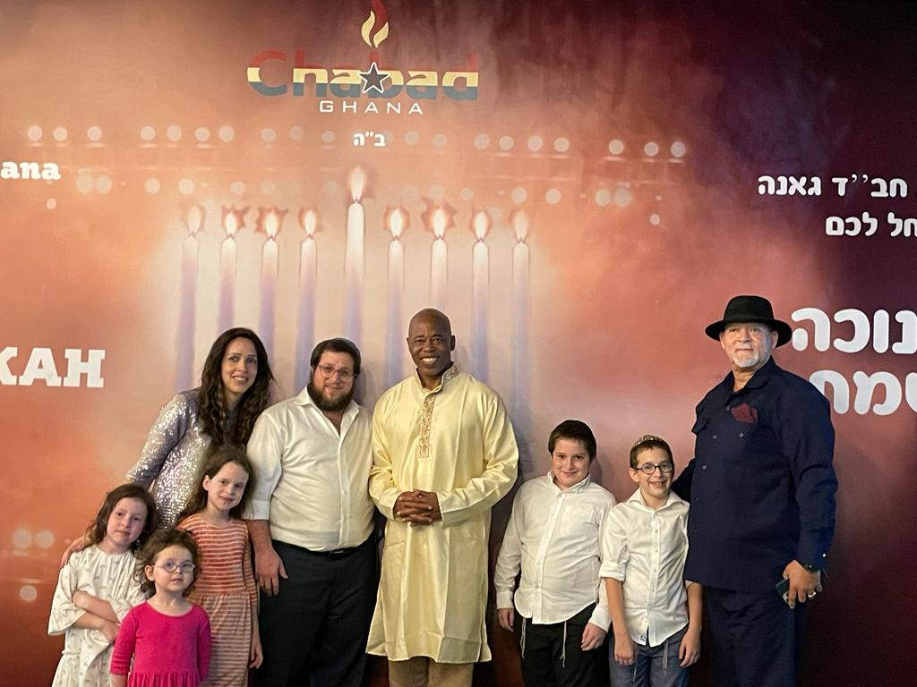

**New York City Mayor-elect Eric Adams joined Rabbi Noach Majesky and his family at a Hanukkah celebration in Accra, Ghana, Dec. 1, 2021. (Photo courtesy of Chabad)**

(New York Jewish Week via [JTA](http://jta.org/)) — Eric Adams [told reporters he planned to engage in “some spiritual cleansing”](https://www.politico.com/states/new-york/albany/story/2021/11/29/eric-adams-invokes-obama-ahead-of-spiritual-journey-to-ghana-1396031) during a trip to Ghana this week. Still, the appearance of New York City’s mayor-elect at a Hanukkah party Wednesday in Accra came as a surprise.

Adams joined Rabbi Noach Majesky, a Brooklyn expat who is Chabad’s emissary in Ghana, onstage for an event to celebrate the fourth night of Hanukkah, according to a video distributed by the Orthodox movement’s headquarters.

It was at least the second Hanukkah celebration with Chabad this year for Adams, the favored mayoral candidate for much of New York’s Orthodox communities. (He [has vowed to go out every night as mayor](https://nypost.com/2021/11/12/nightlife-mayor-eric-adams-takes-manhattan-for-nyc-restaurant-opening/), to demonstrate that the city is thriving despite the ongoing pandemic.)

**Participated in the First Night**

**Menorah Lighting in Manhattan**

On Sunday night, he joined Chabad in Midtown Manhattan to light the menorah the movement has erected there, which it bills as the largest in the world. There, he praised Menachem Mendel Schneerson, the late rabbi who led the Chabad movement, known among his adherents as the Rebbe.

“As a member of the Brooklyn community, and the rich Crown Heights community, we know what the Rebbe did for all of us and how he spread the importance of Hanukkah, and the celebrations that we are seeing all over the world now,” [Adams said from a cherry picker at the top of the 36-foot menorah](https://collive.com/mayor-elect-adams-thanks-the-rebbe-at-worlds-largest-menorah-in-ny/).

The menorah in Accra was more modest, but Adams was just as lavish in his praise for Schneerson and those, such as Majesky, who have moved all over the world to advance his message.

“My ancestors left these shores in slavery. I came back to Africa with the mayoral team. It is because no matter what pain we experience we must turn our pain into purpose. Nothing personified that more than the Grand Rebbe in Crown Heights,” Adams said, to applause from the assembled crowd.

Adams added, “He told the men and women of his community to go out across the globe and open Chabad houses and spread the energy and spirit of Judaism. We are looking at the seeds that he planted.”

**The Majesky Family Moved to**

**Ghana [in West Africa] in 2015**

Majesky and his wife, Altie, along with their children, moved to Accra in 2015. There, they serve a tiny community of local Jews, largely Israeli businesspeople and their families, according to [an article published by Chabad.org](https://www.chabad.org/library/article_cdo/aid/4451026/jewish/What-Its-Like-to-Be-Jewish-in-Ghana.htm).

Majesky’s brother, Berel Majesky, is a major figure in Crown Heights as the founding director of the Friendship Circle Brooklyn, a nonprofit associated with the Jewish Children’s Museum that supports children with special needs.

Adams heard about the local event through his New York City relationships, according to Yaacov Behrman, who does public relations for the Chabad-Lubavitch headquarters in Brooklyn and who distributed the video.

“He heard about Chabad’s event, led by a Crown Heights rabbi, and was happy to participate,” Behrman told the New York Jewish Week. “The mayor-elect has been a friend to Chabad, and the Lubavitch community in Crown Heights for over 10 years.”

In Accra, Adams told the partygoers that he had come to the country to “close the open wound of slavery and reconnect with ancestors,” adding that he knows that Jews, too, have open wounds inflicted by history. But he said it is possible to overcome division and trauma.

“We’re going to show that we’re members of the greatest race alive, and that’s the human race. Let’s make sure it’s a safe Hanukkah for our families and the children and for humanity,” Adams said. “I’m happy to be here in Ghana with you showing how great we are as a people.”

The mayor-elect is set to return to New York on Dec. 8.

*Reprinted from the December 1, 2021 dispatch of the JTA (Jewish Telegraphic Agency) in collaboration with the Jewish Week of New York.*

**Thoughts on the Parsha**

*The brothers were unable to answer him because they were frightened of his face*. (Gen. 45:3)

The brothers were not merely frightened of him, they were actually frightened of his face. Up until now, whenever Yosef spoke to his brothers, he covered his face with a veil. When he revealed himself to his brothers, he said," I am Yosef," and removed the veil. It was then that the brothers saw the exact resemblance to their father, Yaakov. (Zichron Yisrael)

*And they told him saying, "Yosef is still alive and he is the ruler over all the land of Egypt."* (Gen. 45:26)

Yaakov had yearned for many years for Yosef, and one can imagine his joy at learning that Yosef was alive. That Yosef ruled over Egypt should have been insignificant next to the fact that he was alive. The brothers knew that Yaakov was concerned about Yosef's spiritual welfare as well. They were telling Yaakov that Yosef did not let the environment of Egypt influence him; he was "ruler over Egypt," Egypt did not "rule over him." (Rav David Hollander)

*Reprinted from Reprinted from the 5757/1996 Vayigash edition of L’Chaim Weekly Compiled by Rabbi Moshe Bogomilsky and printed in Vedibarta Bam*

# Rav Avigdor Miller

# On the Wicked Judges



**QUESTION:** **Why are there so many criminals running around on the streets today?**

**ANSWER:** The answer is because there are so many wicked judges sitting in courtrooms today. Years ago, the judge wasn’t a criminal himself. He wasn’t a tzadik, but he wasn’t wicked either. Today the judges themselves are criminals. They are חברי גנבים – they’re the friends of criminals.

You have to know that the judges today are the enemies of our society. They are absolutely depraved characters. If a judge will let out on bail, on $600 bail, a man, a drunken driver who killed three innocent people in his drunken driving, that’s a criminal act. The judge is a criminal. Or there’s another judge who let out on bail a man who tried to kill a policeman, $500 bail.

The judges and the lawyers are murderers because they are encouraging it. And if the people had backbone, they would see to it that the judge would feel the wrath of public opinion.

Years ago, not only did they catch up with the criminals but many times they ended up in the penitentiary for the rest of their lives. Some ended up in the electric chair; even better. The electric chair you have to know is the best rehabilitation for criminals. There’s no way that more readily solves the rehabilitation problem than the electric chair. But our friend Governor Carey has a soft heart. He likes getting a lot of votes from the criminal element – I won’t say who they are. And therefore, he is committed to the cause of opposing the death penalty.   
TAPE # 307 (April 1980)

*Reprinted from the November 25, 2021 email of Toras Avigdor (Tape 843)*

**Rabbi Berel Wein on**

**Parshat Vayigash 5782**

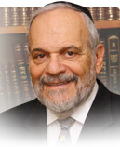

As the story of Joseph and his brothers reaches its dramatic climax in this week’s Torah reading, we are left with many unanswered questions regarding this unique narrative. One unanswered question is how much did our father Jacob really know about the events previously described in the Torah readings?

**The Opinion of Rashi**

There are various streams of thought regarding this matter. Rashi and the Midrash seem to believe that Jacob, by the end of his life, certainly was aware of the entire drama and of the participants in the story. He indirectly refers to it on his deathbed, especially regarding Shimon and Levi, for their aggressive behavior towards Joseph.

Jacob also seemingly complements Yehuda for his original moderation in dealing with Joseph, and for his later courage and heroism in defending Benjamin and confronting Joseph. It is, perhaps, safe to say that even if Jacob was unaware of all the details of the story, he knew the general facts of the narrative, and was able to piece it together for himself.

  Jacob’s reaction is seen in the blessings he gives to his children, his final words to all the participants in this drama. It is difficult to believe that Jacob would not have asked Joseph how he came to live in Egypt, and how he rose to such a prominent position of power and influence. One of the hallmarks of the relationship between Jacob and Joseph was the fact that, more so than the usual relationship between parent and child, they understood each other, and were sensitive to all the nuances of character that they possessed

**The Other Opinion on the Matter of What Jacob Knew**

There are other sources and commentators that seem to feel that Jacob never really knew the entire story that led Joseph “to cover the eyes of Jacob with his hand” so that he would never know the rift in the family, and the consequences that eventually brought the children of Israel to the exile in Egypt.

All parents know that there are things about their children and their progeny that they do not wish to be informed about. Sometimes, in family matters, ignorance is truly bliss, and in his golden years, surrounded by family, Jacob felt comforted. There also is a natural tendency among children to attempt to hide unwelcome news, evil tidings, and unnecessary aggravation from their parents.

Now that the family has been reunited in Egypt and is living in the land of Goshen in comfort, if not even luxury, of what purpose would there be to retell the bitter story of family discord? The Torah seems to indicate that the last 17 years of Jacob's life were truly his golden years, surrounded by family, and respected and honored by the society it in which he now found himself living. Why burden the old man with a story that would only reopen wounds and create unnecessary anxiety and even regret?

Jacob will go to his final resting place emotionally whole, reconciled even with his brother Eisav, and certainly at peace with his children and family. Whichever of the narratives we choose to follow, the Torah has told us all we need to know about Joseph and his brothers and the descent of the Jewish people into Egyptian society, and their eventual slavery and their redemption.

*Reprinted from the current website of rabbiwein.com*

**The Lesson Jewish Parents Can Learn from Yehuda**

**From the Talks of the Lubavitcher Rebbe**

**Rabbi Menachem Mendel Schneerson, Zt”l**

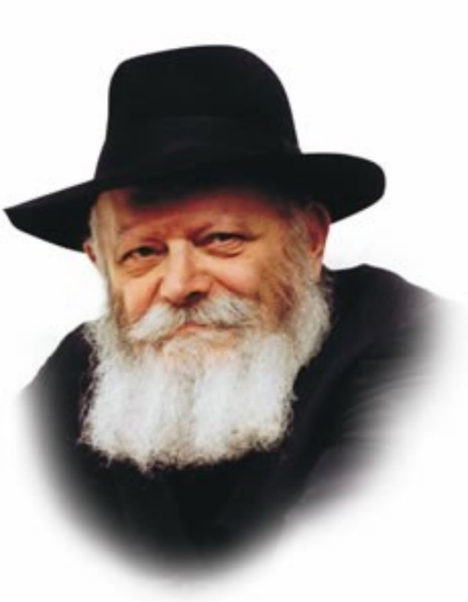

This week's Torah portion, Vayigash, begins with the words "Yehuda came near."

Yehuda approached Yosef and asked that his younger brother, Binyamin, be released so that he could bring him to their father, Yaakov.

Our Sages tell us that Yehuda was prepared for all possibilities when he approached Yosef, even the possibility of war. Yehuda was willing to do all that was necessary to free Binyamin and return him to his father.

Why did Yehuda adopt such a strong stance? The answer is that Yehuda was personally responsible for Binyamin's welfare, as he explained, "For your servant became surety for the lad." Yehuda had promised his father that he would take care of Binyamin and bring him home; thus, he was willing to do anything, even wage battle, to fulfill his promise.

But how could Yehuda have even imagined that he could win a confrontation with Yosef? Yehuda and his brothers were few in number. Yosef, by contrast, was the second highest ruler in all of Egypt, with the entire populace of the country under his command.

In truth, Yehuda could never have been victorious in a war conducted against Yosef. Nonetheless, Yehuda was ready to take even this drastic step should it become necessary. He knew he was responsible for Binyamin, and accepted his role as guardian without question.

True, Yaakov had other remaining sons, all of whom were healthy and sound. But Yehuda realized that self-sacrifice is required when the life of even one Jewish child is at stake.

To save Binyamin, Yehuda was willing to give up his own life. This contains an important lesson for every Jewish father and mother. When G-d grants them the blessing of a child, it carries with it a great responsibility. Sometimes it is even necessary for parents to demonstrate self-sacrifice, to make sure that nothing untoward ever happens to even one of their offspring, G-d forbid.

One area in which the greatest efforts must be expended is that of education. Providing a Torah-true education for Jewish children is so important that parents must be willing to demonstrate even the highest levels of self-sacrifice in order to make it possible.

*Reprinted from Reprinted from the 5757/1996 Vayigash edition of L’Chaim Weekly, adapted from Likutei Sichot, volume 1.*

**Final Torah Thought on the Parsha**

*Then Yehuda came near to him* (Gen. 44:18)

The word the Torah uses for "came near," vayigash, implies that Yehuda and Yosef came very close together. Many years later the descendants of Yehuda and Yosef split, and actually formed two separate kingdoms. Vayigash alludes to the time of the Redemption when we all will unite as one kingdom under one king, Moshiach. (Bereishit Rabba)

*Reprinted from Reprinted from the 5757/1996 Vayigash edition of L’Chaim Weekly Compiled by Rabbi Moshe Bogomilsky and printed in Vedibarta Bam*